Year 2006

VCE

Specialist Mathematics
Solutions
Trial Examination 1



KILBAHA MULTIMEDIA PUBLISHING  PO BOX 2227  KEW VIC 3101  AUSTRALIA | TEL: (03) 9817 5374  FAX: (03) 9817 4334  chemas@chemas.com  www.chemas.com

© Kilbaha Pty Ltd 2006

ABN 47 065 111 373
IMPORTANT COPYRIGHT NOTICE

- This material is copyright. Subject to statutory exception and to the provisions of the relevant collective licensing agreements, no reproduction of any part may take place without the written permission of Kilbaha Pty Ltd.
- The contents of this work are copyrighted. Unauthorised copying of any part of this work is illegal and detrimental to the interests of the author.
- For authorised copying within Australia please check that your institution has a licence from Copyright Agency Limited. This permits the copying of small parts of the material, in limited quantities, within the conditions set out in the licence.
- Teachers and students are reminded that for the purposes of school requirements and external assessments, students must submit work that is clearly their own.
- Schools which purchase a licence to use this material may distribute this electronic file to the students at the school for their exclusive use. This distribution can be done either on an Intranet Server or on media for the use on stand-alone computers.
- Schools which purchase a licence to use this material may distribute this printed file to the students at the school for their exclusive use.

- The Word file (if supplied) is for use ONLY within the school.

- It may be modified to suit the school syllabus and for teaching purposes.

- All modified versions of the file must carry this copyright notice.

- Commercial use of this material is expressly prohibited.

Question 1

a. 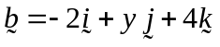
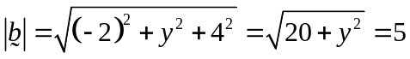 squaring both sides M1
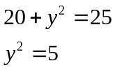
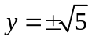 A1

b. 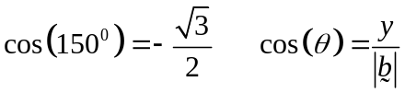
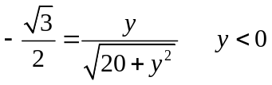 M1
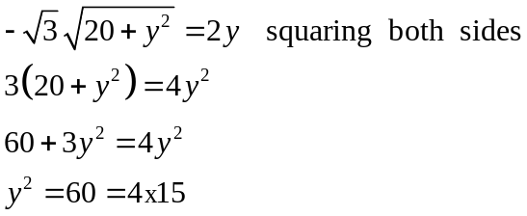
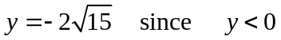 A1

Question 2

a.
inflow 0.5 kg/litre
at 2 litre/min

outflow at 3 litre/min

Now 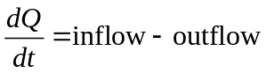
and the volume 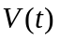 of the tank at a time t. 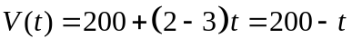

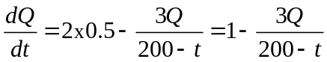 A1

b. 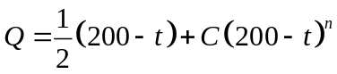
differentiating LHS 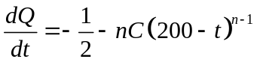 M1

RHS 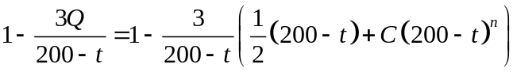
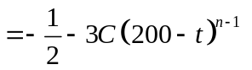 therefore 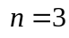 A1

Question 3
a. Let 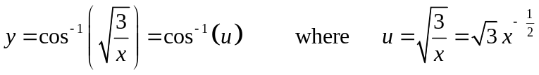
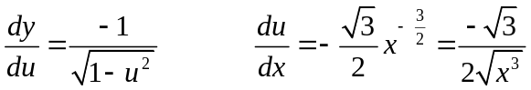 M1
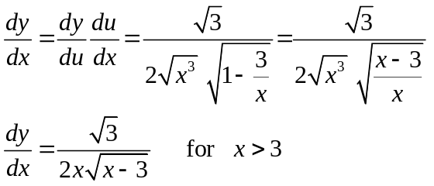
So shown 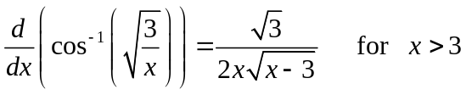 A1

b. 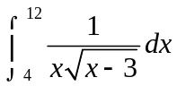
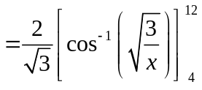 M1
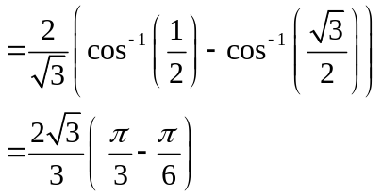
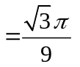 A1

Question 4

a. 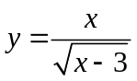 using the quotient rule
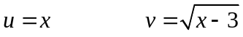
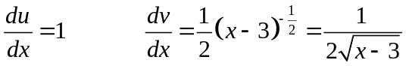 M1
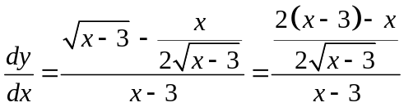
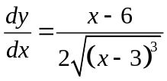 therefore 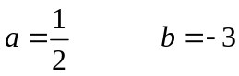 A1

b. the area 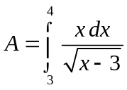 let 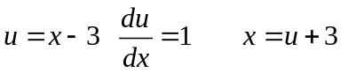
terminals when 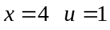 and when 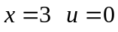
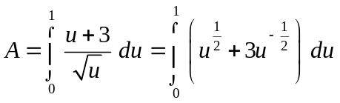 M1
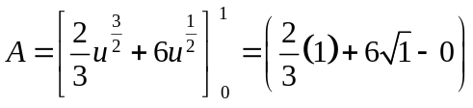
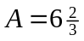 A1

Question 5

a.

N
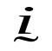
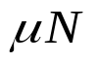
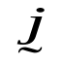
N

A1
mg
b. resolving up parallel to the slide in the direction.
(1) 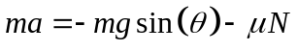
resolving perpendicular to the slide in the direction.
(2) 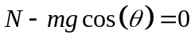 (2) 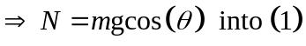 M1
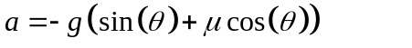 A1
Using constant acceleration formulae 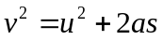 with 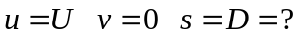
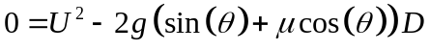
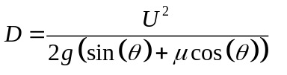 A1

Question 6

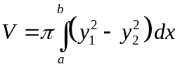
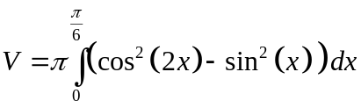 M1
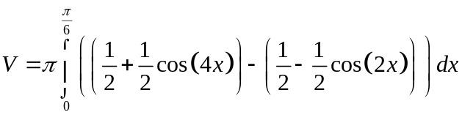 M1
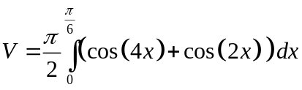 A1
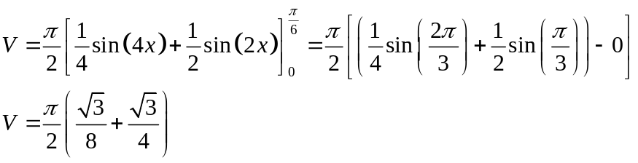
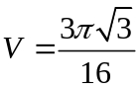 A1
Question 7

a. 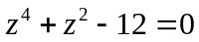
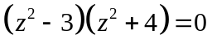 M1
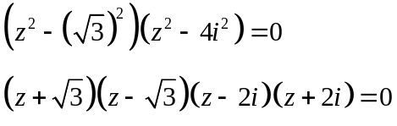
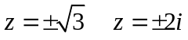 A1

b.
equating real and imaginary parts
real 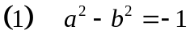 M1
imaginary 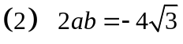 from 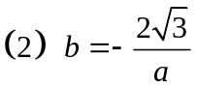 substitute into 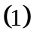
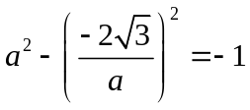 M1
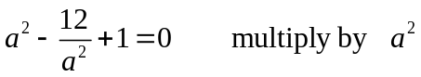
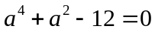 from i. since a is real 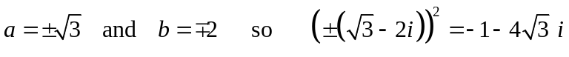
therefore if 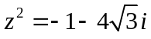 then 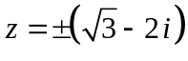 A1

c. 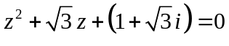
using the quadratic formulae with 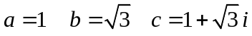
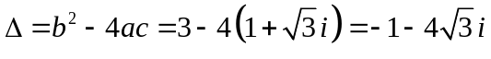 A1
so 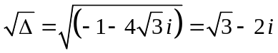
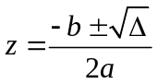
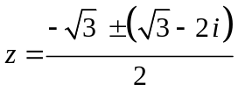 M1
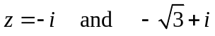 A1
Question 8 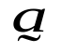
O
A
Q
B
C
P
a. 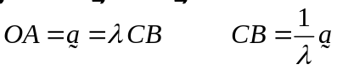
since P is the midpoint of 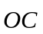 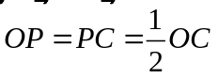
since Q is the midpoint of 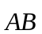 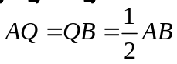

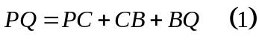
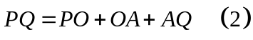 M1
adding these two equations gives

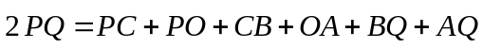 M1
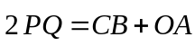
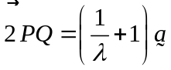
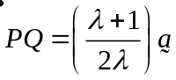 A1

b. the length of 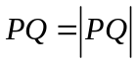 is equal to 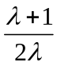 times the length of
so the ratio of the length is A1
Question 9

a. vertical asymptotes at 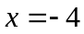 and  so the denominator is 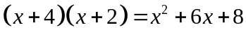 therefore 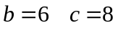 A1
the turning point is 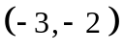
when 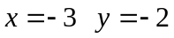 so 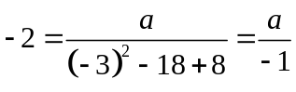
therefore  A1

b. the area 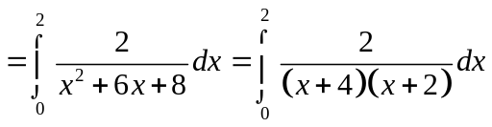
by partial fractions 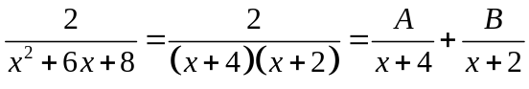
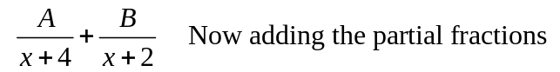

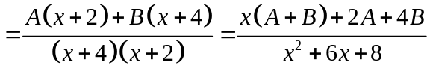

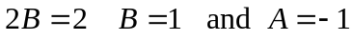 A1
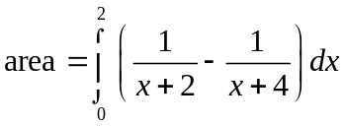
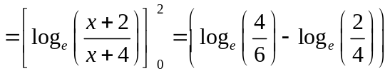 A1
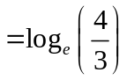 therefore 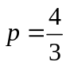 A1

END OF SUGGESTED SOLUTIONS

